**SOFTWARE VERIFICATION, VALIDATION AND TESTING**

TESTING DOCUMENTATION

World of Tanks website Solidity testing

Prepared by:

**Dženis Kajević**

Proposed to:

**Samed Jukić, Assist. Prof. Dr.**

**Aldin Kovačević, Teaching Assistant**

January 7, 2023.

TABLE OF CONTENTS

Contents

1. Introduction 3

1.1. About the Project 3

1.2. Project Functionalities and Screenshots 3

2. Test Plan 6

2.1. Scope 6

2.2. Testing Environment and Tools 6

3. Test Execution 6

3.1. Tests without required login 6

3.1.1. Scenario: Download the Game Launcher 6

3.1.2. Scenario: Accessing the Global Map (settings and leaderboards) 8

3.1.3. Scenario: Registering and Logging in 11

3.1.4. Scenario: Redirecting to the official World of Tanks YouTube channel 12

3.2. Tests with required login 13

3.2.1. Scenario: Edit profile information 13

3.2.2. Scenario: Redeem bonus code 14

3.2.3. Scenario: Refer a friend 14

3.2.4. Scenario: Clan application 15

4. Conclusion 16

4.1. Testing Summary 16

4.2. Final Thoughts 17

# 1. Introduction

## 1.1. About the Project

For this project, I have decided to test various functionalities of the official World of Tanks website.

This website has multiple uses for the game’s playerbase. It serves multiple purposes:

* Source for downloading the game’s launcher,
* Account creation and editing,
* Game news and events tracker,
* Leaderboard tracker,
* In-game shop,
* Etc.

In this particular case, the company that has developed this game has decided to bind some of the functionalities of the game’s website to their own, effectively making me test both of those websites at certain points.

The websites which were tested in this project are:

* <https://worldoftanks.eu/>
* <https://eu.wargaming.net/en>

## 1.2. Project Functionalities and Screenshots

The website allows users / players to:

* Download an installer for the game (Figure ),
* Purchase in-game items in the store (Figure 2),
* Redeem various coupons (Figure 3),
* Create and join other players’ clans (Figure 4),
* Participate in various in-game events, such as the Global Map which shows the leaderboard and status of various involved clans on the world map (Figure 5,
* Register and login with in-game accounts,
* Refer other players, granting rewards to all participating parties,
* Etc.

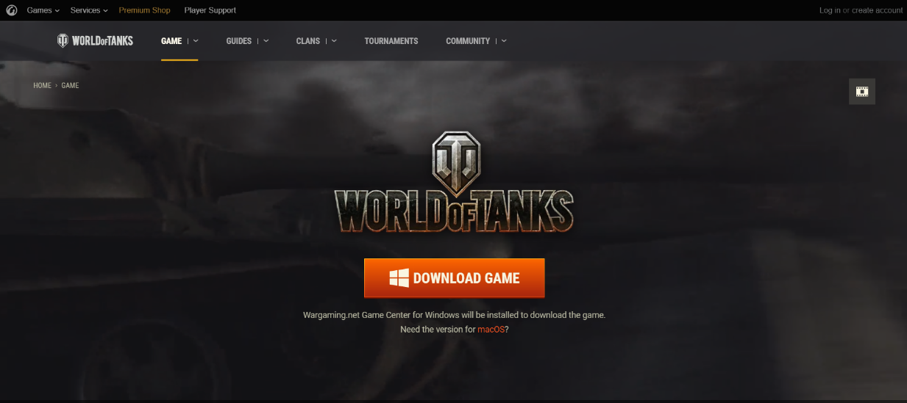

Figure : Download

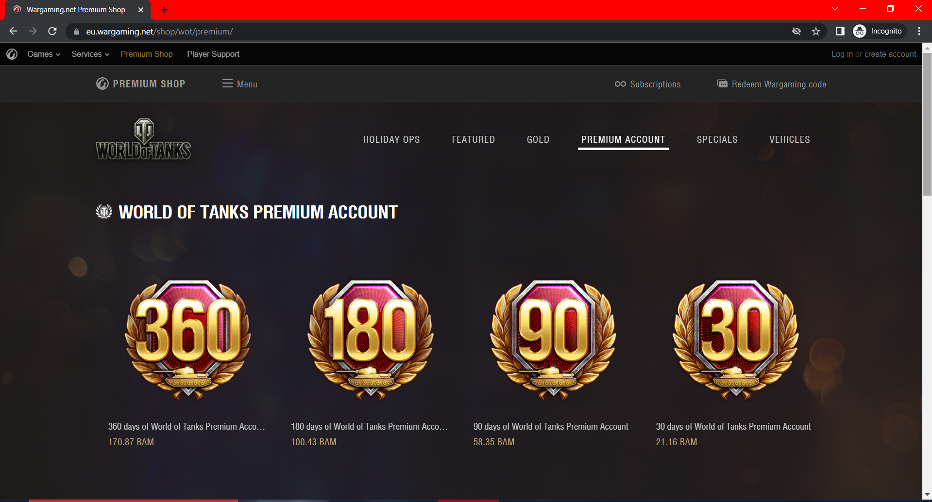

Figure : Premium Shop

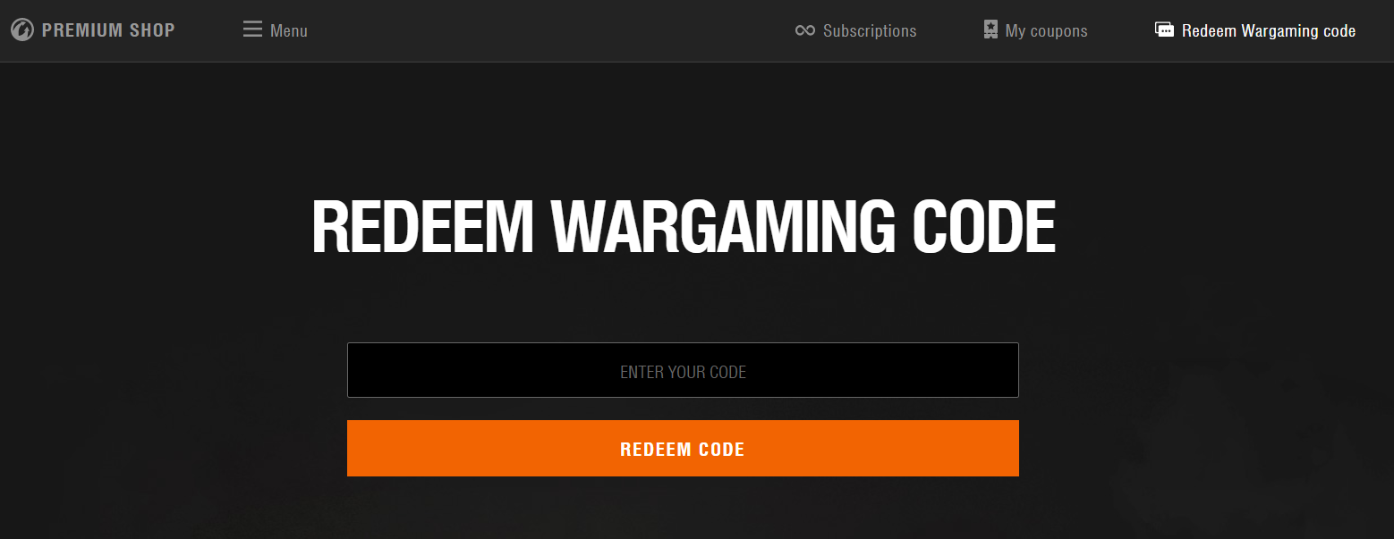

Figure : Redeemable Codes

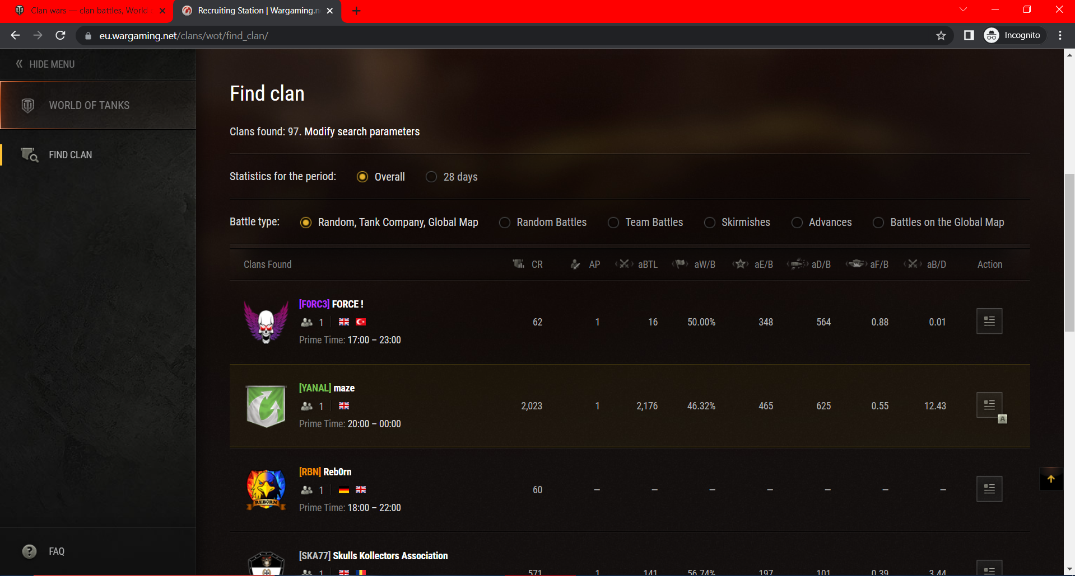

Figure : Clan Finder

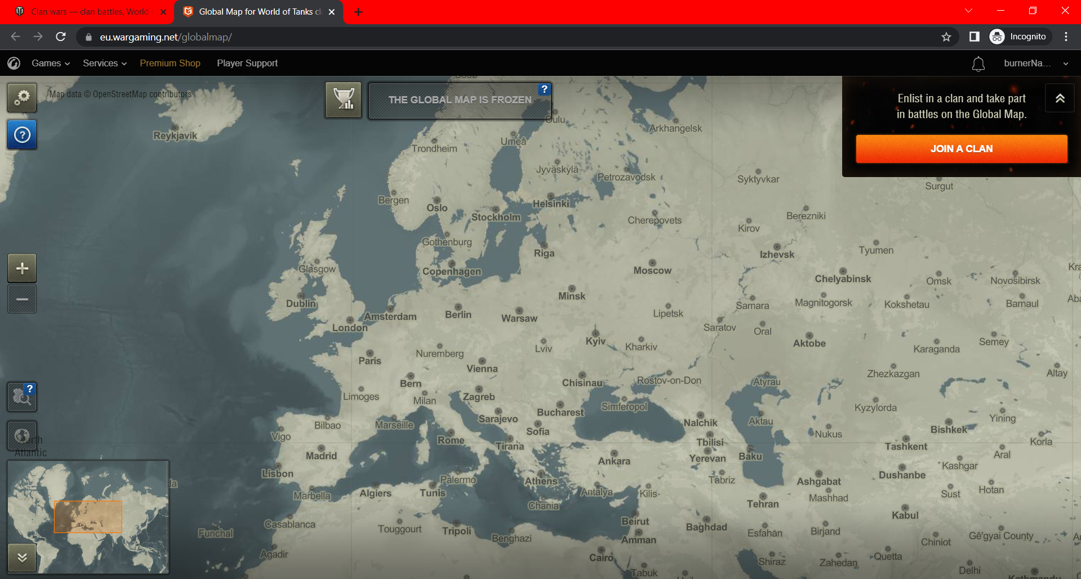

Figure : Global Map Event

# 2. Test Plan

## 2.1. Scope

During the project planning phase, I have decided to try and avoid testing features which only contain static text, change often, require additional personal information and confirmation, and which could potentially waste the time and / or enjoyment of other people. Such ignored features include:

* Contacting customer support
* Purchasing items in the shop
* Testing the “Latest News” panel
* Testing the written guides
* Applying for in-game tournaments and events

## 2.2. Testing Environment and Tools

For the execution of this project I have decided to use Selenium, along with JUnit Jupiter, and the Java programming language.

I was thinking of using the Selenium IDE extension, but have decided to ignore it, since that would potentially lower the amount of practice I would obtain compared to manually writing the tests.

# 3. Test Execution

For my project structure, I have divided the tests into two sections:

* Tests which require the user to be logged in
* Tests which don’t require the user to be logged in

The text fixtures were decided for each test based on which one of these two sections they belong to.

Tests which require the user to be logged in will immediately run the “login” part of testing as soon as one of the tests starts.

## 3.1. Tests without required login

### 3.1.1. Scenario: Download the Game Launcher

Users want to be able to download the launcher for the game, and start installing the actual game as soon as possible.

|  |  |  |  |  |
| --- | --- | --- | --- | --- |
| **Test Name:** Test launcher file download | | | | |
| **Description:**  Click on the download button and check whether the file has been downloaded successfully | | | | |
| **Pre-condition(s):** | | | | |
| **Test Steps:**  1. Go to the main page  2. Close the promo div  3. Go to the download page  4. Click the download button (and confirm “risky file” if necessary)  5. Check if the file was downloaded and delete it if it was | **Test Data:**  - Download location, file name and extension for the FileUtil.checkFileDownload() function | **Expected Result:**  The game launcher was successfully downloaded, and deleted after confirming the download | **Actual Result:**  The game launcher was successfully downloaded, and deleted after confirming the download | **Status:**  PASS |
| **Notes:** A custom helper class was created for the file manipulation part: FileUtil | | | | |

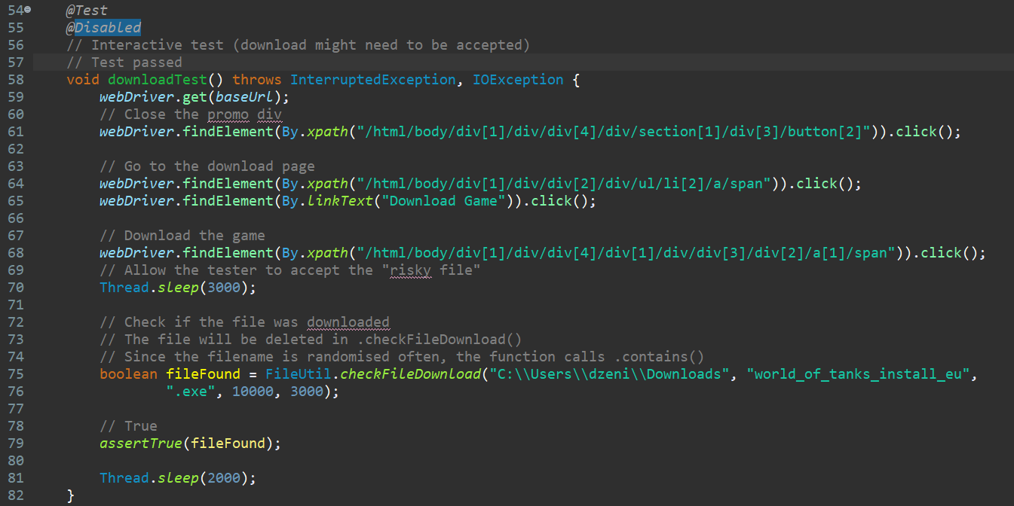

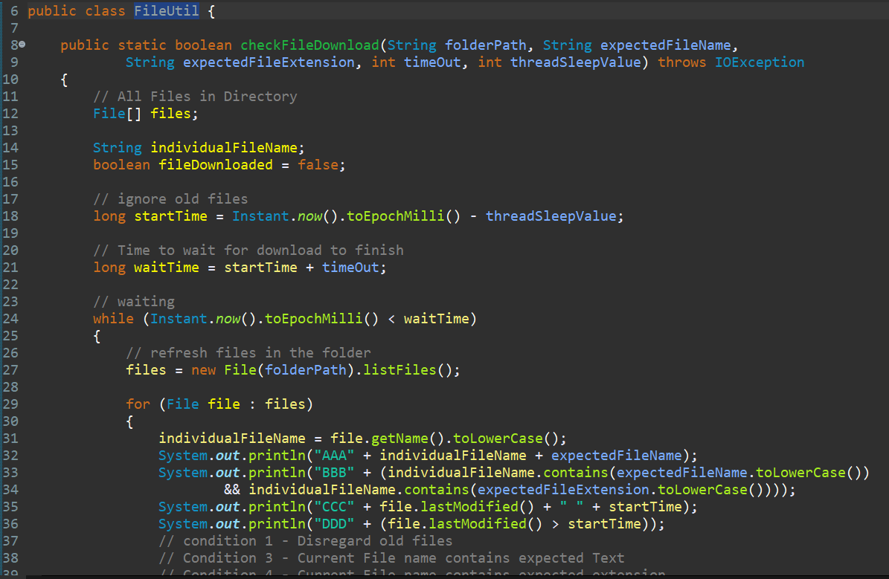

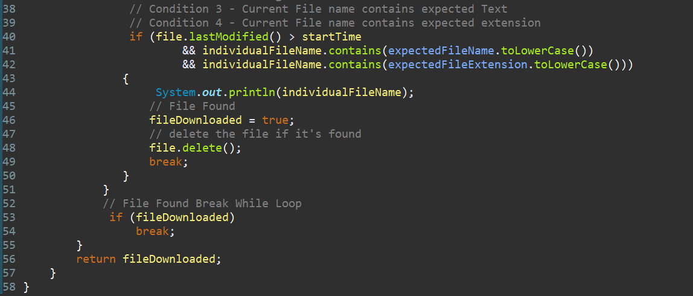

### 3.1.2. Scenario: Accessing the Global Map (settings and leaderboards)

Users want to be able to access the global map event page, regardless if it is active or not, check the previous (or current) state of the event and change settings for the map based on their preferences.

|  |  |  |  |  |
| --- | --- | --- | --- | --- |
| **Test Name:** Test whether the global map is frozen properly | | | | |
| **Description:**  Access the global map, and if it is frozen, go to the leaderboard and assert that only information from the previous event is kept | | | | |
| **Pre-condition(s):** | | | | |
| **Test Steps:**  1. Go to the main page  2. Close the promo div  3. Go to the global map page  4. Swap handles due to redirect  5. Wait for the “Global Map Freeze” popup and close it  6. Go to the leaderboards and assert whether there is a message saying: “event finished” | **Test Data:** | **Expected Result:**  The global map is indeed frozen and the leaderboards are not changing | **Actual Result:**  The global map is indeed frozen and the leaderboards are not changing | **Status:**  PASS |
| **Notes:** This test can only be used if the map is frozen. It unfreezes for a few days every few months. | | | | |

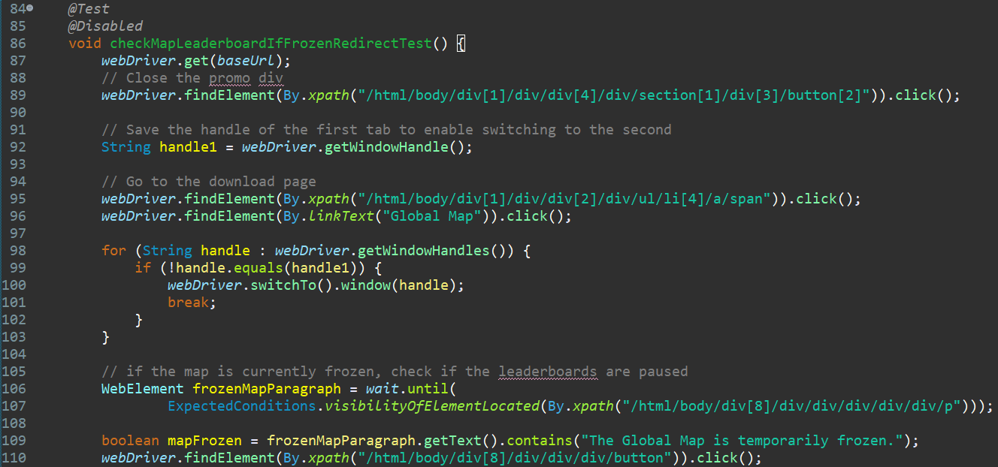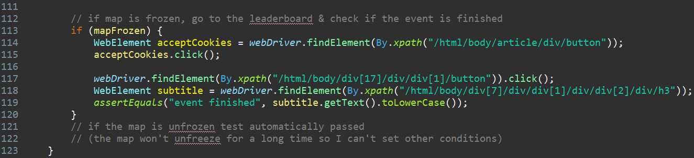

|  |  |  |  |  |
| --- | --- | --- | --- | --- |
| **Test Name:** Change the language on the global map | | | | |
| **Description:**  Access the global map, change the language to German, assert that it succeeded, change it back to English and assert again | | | | |
| **Pre-condition(s):** | | | | |
| **Test Steps:**  1. Go to the global map page  2. Close the promo div  3. Go to the global map page  4. Wait for the “Global Map Freeze” popup and close it  5. Access the settings button and change the language to German  6. Close the settings menu, which causes a page reload  7. Assert that the language has indeed changed  8. Repeat steps 5-7 for the English language | **Test Data:** | **Expected Result:**  The language used on the global map has changed to German and back to English after the test has finished | **Actual Result:**  The language used on the global map has changed to German and back to English after the test has finished | **Status:**  PASS |
| **Notes:** This test might not be able to run properly if the map is not frozen, since there will most likely be 1 missing popup. | | | | |

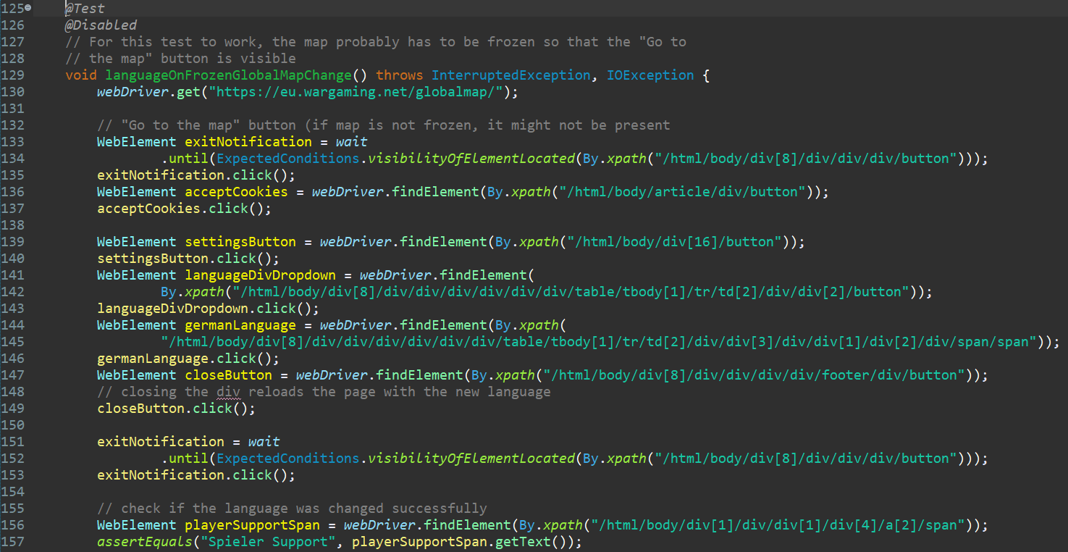 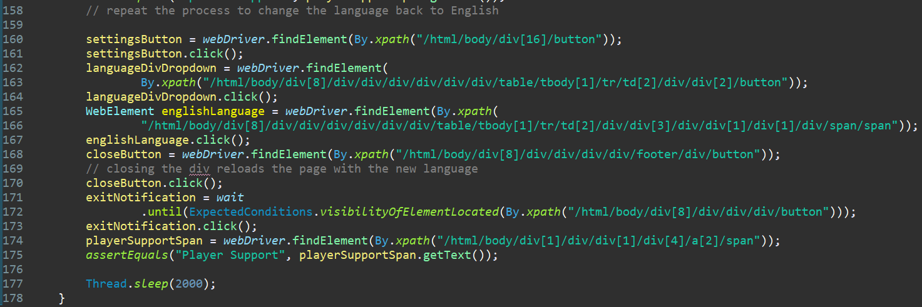

### 3.1.3. Scenario: Registering and logging in

Users want to be able to create a new account and / or log in to the website and games of that company.

|  |  |  |  |  |
| --- | --- | --- | --- | --- |
| **Test Name:** Test register functionality | | | | |
| **Description:**  Fill out the registration form, accept the EULA and receive a new account. | | | | |
| **Pre-condition(s):** | | | | |
| **Test Steps:**  1. Go to the main page  2. Access the account creation page  3. Fill out the registration form  4. Accept the privacy policy  5. Accept the EULA  6. Click the register button  7. Assert that a message saying: “account created” pops up | **Test Data:**  Email:  ”kanes2487511@dentaltz.com”;  Name: "burnerName120949111";  Password: “burnerPassword_123”;  ConfirmPassword:  “burnerPassword_123” | **Expected Result:**  An account was successfully created. | **Actual Result:**  An account was successfully created. | **Status:**  PASS |
| **Notes:** There is no need to confirm the email address for the account, so I have used a random temporary email to create a new account.  The test kept trying to register before the EULA was accepted, so a 1 second timeout was added to prevent that. | | | | |

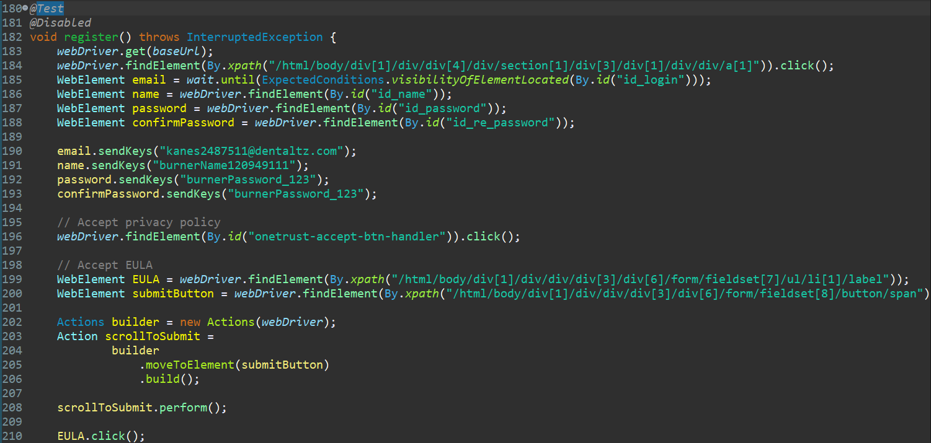 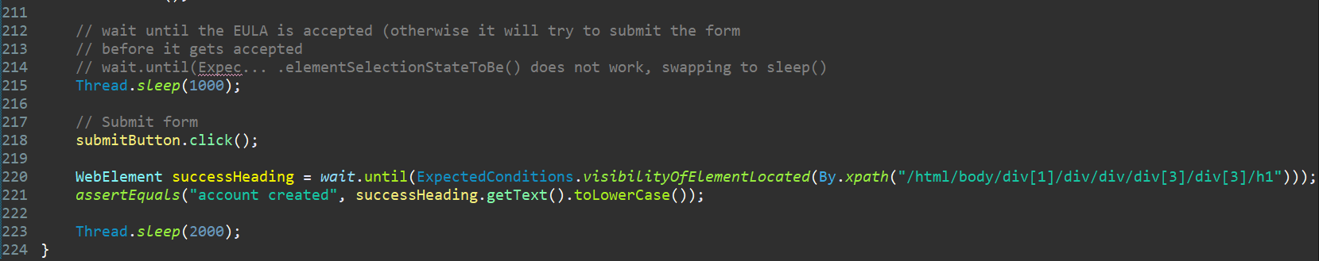

|  |  |  |  |  |
| --- | --- | --- | --- | --- |
| **Test Name:** Test login functionality | | | | |
| **Description:**  Fill out the login form, and assert that the username pops up in the top-right corner. | | | | |
| **Pre-condition(s):** | | | | |
| **Test Steps:**  1. Go to the main page  2. Close the promo div  3. Access the login page  4. Fill out the login form  5. Click the login button  6. Assert that the account name in the top-right corner on the main page matches the username | **Test Data:**  Email:  ”kanes2487511@dentaltz.com”;  Password: “burnerPassword_123”; | **Expected Result:**  The user has successfully logged in. | **Actual Result:**  The user has successfully logged in. | **Status:**  PASS |
| **Notes:** | | | | |

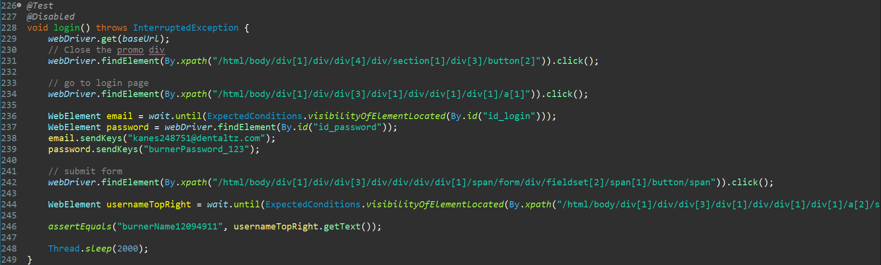

### 3.1.4. Scenario: Redirecting to the official World of Tanks YouTube channel

Users want to be able to visit the game’s official YouTube channel from its website.

|  |  |  |  |  |
| --- | --- | --- | --- | --- |
| **Test Name:** Test redirect to YouTube channel | | | | |
| **Description:** Assert that the redirect URL matches the actual YouTube channel’s URL | | | | |
| **Pre-condition(s):** | | | | |
| **Test Steps:**  1. Go to the main page  2. Close the promo div  3. Scroll to the bottom of the page  4. Click on the redirect link  5. Swap to the new tab with handles  6. Assert that the URL matches the expected one | **Test Data:** | **Expected Result:**  The user was redirected to the correct website after clicking on the link. | **Actual Result:**  The user was redirected to the correct website after clicking on the link. | **Status:**  PASS |
| **Notes:** | | | | |

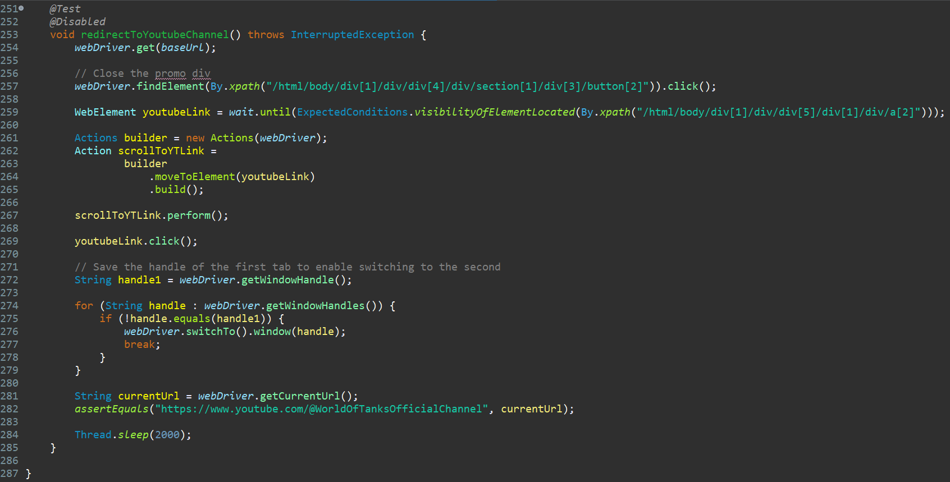

## 3.2. Tests with required login

### 3.2.1. Scenario: Edit profile information

Users want to be able to edit their profile information through the account management screen.

|  |  |  |  |  |
| --- | --- | --- | --- | --- |
| **Test Name:** Test birth date removal | | | | |
| **Description:**  If a birth date has been set for the account, the user can remove it at will | | | | |
| **Pre-condition(s):** The user is logged in using the text fixture | | | | |
| **Test Steps:**  1. Go to the main page  2. Click on the username  3. Remove the birth date  4. Assert that the new birth date is empty | **Test Data:** | **Expected Result:**  The user has successfully removed his birth date from the account information. | **Actual Result:**  The user has successfully removed his birth date from the account information. | **Status:**  PASS |
| **Notes:** The birth date can only be set and removed once per day, so this test will not pass under certain circumstances. | | | | |

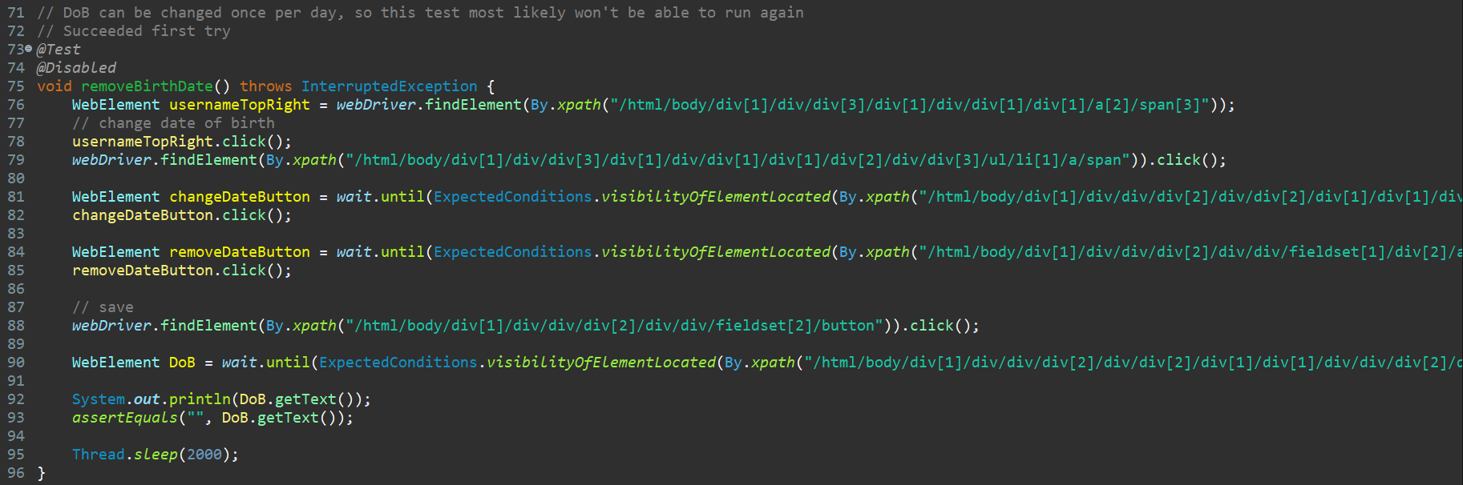

### 3.2.2. Scenario: Redeem bonus code

Users want to be able to redeem bonus codes that provide discounts or free in-game items.

|  |  |  |  |  |
| --- | --- | --- | --- | --- |
| **Test Name:** Test incorrect bonus code redemption | | | | |
| **Description:**  If an incorrect code is entered, the redemption should fail | | | | |
| **Pre-condition(s):** The user is logged in using the text fixture | | | | |
| **Test Steps:**  1. Go to the main page  2. Click on the username  3. Remove the birth date  4. Assert that the new birth date is empty | **Test Data:**  InputCode:” RANDOMCODE” | **Expected Result:**  The redemption process fails due to the code being invalid. | **Actual Result:**  The redemption process fails due to the code being invalid. | **Status:**  PASS |
| **Notes:** | | | | |

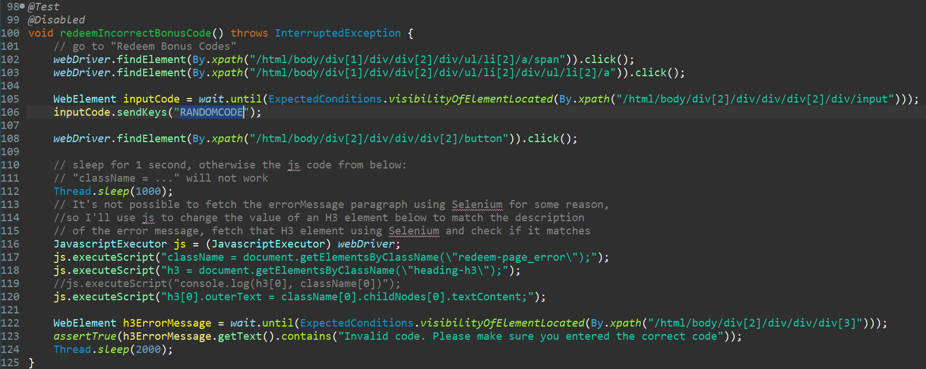

### 3.2.3. Scenario: Refer a friend

Users want to be able to invite their friends to play the game with them, allowing both parties to receive various bonuses and gifts as a result.

|  |  |  |  |  |
| --- | --- | --- | --- | --- |
| **Test Name:** Test referral link generation on young accounts | | | | |
| **Description:**  If an account is too young, the website should refuse to generate a referral link | | | | |
| **Pre-condition(s):** The user is logged in using the text fixture | | | | |
| **Test Steps:**  1. Go to the main page  2. Click on the Community dropdown  3. Go to the Refer a Friend page  3. Scroll down to the referral code generation part  4. Assert that the code is not being generated and save the amount of matches played requirement  5. Go to the profile page and assert that the amount of matches played is less than the required amount | **Test Data:** | **Expected Result:**  The referral link is not generated due to the account not having enough matches played. | **Actual Result:**  The referral link is not generated due to the account not having enough matches played. | **Status:**  PASS |
| **Notes:** The test will fail if used on an account that has played more than (currently) 600 matches. | | | | |

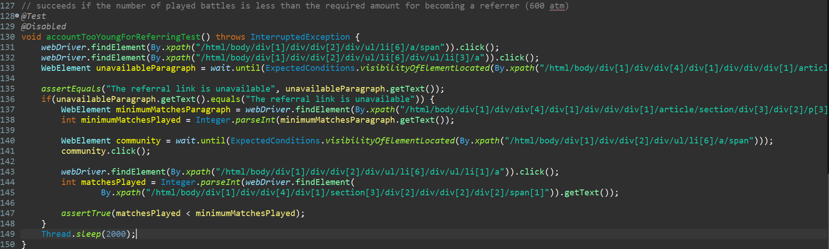

### 3.2.4. Scenario: Clan application

Users want to be able to join clans, allowing them to more easily find people to interact with, to receive various activity rewards and to be able to participate in various clan-based events.

|  |  |  |  |  |
| --- | --- | --- | --- | --- |
| **Test Name:** Test clan application | | | | |
| **Description:**  The player applies to a clan that requires confirmation from the leaders and verifies that the application went through. | | | | |
| **Pre-condition(s):** The user is logged in using the text fixture | | | | |
| **Test Steps:**  1. Go to the main page  2. Go to the clan page  3. Enter the clan name and search for it  4. Swap handles to go to the new tab that opened  4. Select the specified clan and go to their profile page  5. Fill in the recruitment message textArea and send the application  6. Go to the “Find clan” page and click on “My applications”  7. Assert that the application for the selected clan is present there | **Test Data:**  InputClanName: “zZzZz”,  textArea: “Automated testing. Do not accept.” | **Expected Result:**  The application is sent to the clan leaders and appears in the list of applications for that player. | **Actual Result:**  The application is sent to the clan leaders and appears in the list of applications for that player. | **Status:**  PASS |
| **Notes:** Clan applications cannot be cancelled, so in order to run this test, a new clan name will have to be entered or the application would need to expire beforehand. | | | | |

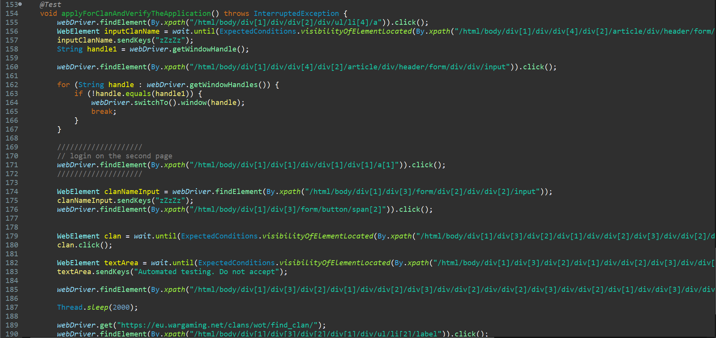



# 4. Conclusion

## 4.1. Testing Summary

Provide a summary of all your executed tests. Something like this would be alright:

|  |  |  |  |
| --- | --- | --- | --- |
| **Testing Tool** | **Total Tests** | **Passed Tests** | **Failed Tests** |
| Selenium, Junit Jupiter, Java | 10 | 10 | 0 |

## 4.2. Final Thoughts

The website is very slow and unoptimized. Even with a WebDriverWait Object set to 50-60 seconds, the tests would sometimes fail due to parts of the website not being loaded in said timeframe.

Another issue that I ran into is that the developers of the website seem to use CSS ::before and ::after often, making Selenium unable to select certain HTML objects, forcing me to resort to using the JavascriptExecutor to manually collect the information that I needed by changing the values of nearby (accessable through Selenium) divs and testing their value that way (3.2.2. Scenario: Redeem bonus code).